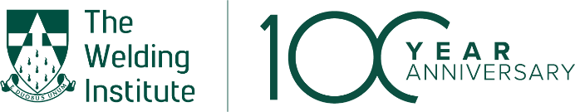
The Welding Institute

Diversity, Equity & Inclusion Charter

We promote Diversity, Equity & Inclusion (D, E &I) within The Welding institute professional membership. We are committed to this institute being open, inclusive and providing professional opportunities irrespective to all. All members irrespective of grade or experience should have equality of opportunity and participation. They are entitled to feel respected, valued, and secure within this institution.

Our Commitment
We will promote good D, E & I behaviours associated with the characteristics outlined in the Equality Act 2010 (Age, Sex, Race (and Ethnicity), Disability, Religion or belief, Sexual orientation, Gender reassignment, Marriage or civil partnerships, Pregnancy and maternity), but also other historic barriers to opportunity, such as socio-economic background, nationality, dialect, education and other forms of exclusion.
- We will ensure that D, E & I is embedded with the institute’s culture, its policies and procedures.
- We aim to attract talented individuals to this institute and empower them to achieve their professional career goals.
- We will celebrate the individual as part of a strong and diverse institute.
- We will promote an expectation for our members to uphold D, E & I behaviours and practices.
- We will promote best practices within the institute and continually strive to improve.

Our Actions
- The institute will have D, E& I Strategy, Policy, and Roadmap documents, which align with this charter, in place and operating. These will be reviewed on an annual basis.
- Collect and report baseline data on D, E & I for the institute and set up the systems to regularly monitor improvement.
- Set targets for improving D, E & I.
- Identify a member of the council who is responsible and accountable for reporting on D, E & I.
- Monitor at Professional Board level and publish data against D, E & I targets to the membership.
- Create a D, E & I working group as part of the Professional Board to promote D, E & I policy, and activities for the membership. This working group is to report progress and share issues with the Professional Board.
- Enable and encourage access for all members to learning, development and awareness initiatives to increase understanding of the importance of D, E & I across the institute.
- Commit to ensure there are procedures in place to encourage diversity at all membership levels of the institute and on the Professional Board.
- Encourage and support members at all levels to progress through and participate in the institute, and where applicable, provide appropriate training and other on-going support.

