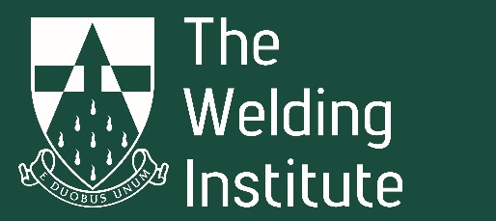

Professional Board Volunteer Recruitment 2022
Closing date for applications 17th July 2022
Please complete the details below and send with any supporting information to theweldinginstitute@twi.co.uk
I would like to apply for membership of Professional Board

Applicant’s name:
Email address:
Contact number:
Date:
GUIDANCE FOR COMPLETION OF APPLICATION
- Applicant should clearly set out how they meet the requirements of the role
- Applicant should clearly set out the qualities and personal experience they bring to the role (with examples)
- Please supply as much information regarding your application as possible including achievements, outcomes and reasons for applying for the role.
- The Selection Panel welcomes applications from all members, particularly those from currently underrepresented groups.
- Applications will be treated in accordance with The Data Protection Act (1998).
- For further information, please contact Theweldinginstitute@twi.co.uk

SUPPORTING INFORMATION
Please summarise below the specific qualities that support your application.

1) How do you meet the requirements of the role?
i.e. Professional Board members will:-.
- Have an understanding and knowledge to actively participate in committee meetings,
- Execute their analytical skills to effectively read and comment on papers and reports
- Contribute to the specific projects and the preparation of reports,
- Deal with requests for information promptly and effectively
- Undertake ad hoc roles as requested in the broader interests of the committee
2) What skills can you bring to the role?
i.e. Professional Board members will have….
- Good verbal communication and interpersonal skills
- Experience of contributing to committee meetings as part of a Team
- The ability to respond to deadlines
- A willingness to take the initiative as required
- The ability to reach a majority view
3) What experience can you bring to the role?
i.e. Professional Board welcomes candidates with a broad range of educational, academic and work place experience.
4) What can you add to the role?
i.e. Professional Board welcomes new ideas, initiatives and skills to broaden our knowledge and ability to support members and the wider engineering community.

I confirm that I have understood the requirements of the application process and potential outcomes and that I hold current professional membership of The Welding Institute

Signed:- …………………………………………………..

Date:- ………………….

