Doc No: TWINB
2017 CWG

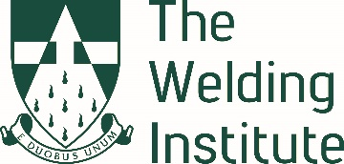

The Welding Institute Teesside Branch AGM

Monday 30th January 2023 commencing at 17:00hrs

VIA ZOOM + IN PERSON at the Stem Centre Middlesbrough College

AGENDA

- Chairman Opens Meeting

- Welcome and Apologies

- Health and Safety Notice

- Minutes of Previous AGM

- Nominations Received

- Election of Branch Committee 2023

- Average Attendance at Meetings Year 2022-2023

8 Branch Secretaries Annual Report

9 Treasurers Annual Report Number 1 Account

10 Programme Secretaries Annual Report

11 Social Secretaries Annual Report and Dinner 2023 details.

12 Younger Members Annual Report

13 Journal Secretary Report

14 Chairman’s Report

15 Any Other Business

16 Date of Next AGM Meeting

Event to follow at 18.00hrs at the Stem Centre Middlesbrough College with attendance in person or via Zoom – World Skills UK-Competition based training and assessment

